Christopher Justice  
INFO 474 A  
February 19, 2016

# Assignment 3: Interactive Snoqualmie Pass Weather Inversion Visualization

## Preliminary Domain and Visualization:

Weather inversions are abnormal events where the temperatures at higher altitudes rise above temperatures at lower altitudes. These events typically occur in mountain ranges when cooler air is forced downward by a warm ridge of high pressure. Inversions are difficult to analyze because there are relatively few data sources for temperatures at different altitudes in mountain ranges and where data is available, there is no way to display the data in a way that allow for the identification of patterns that may emerge over time.

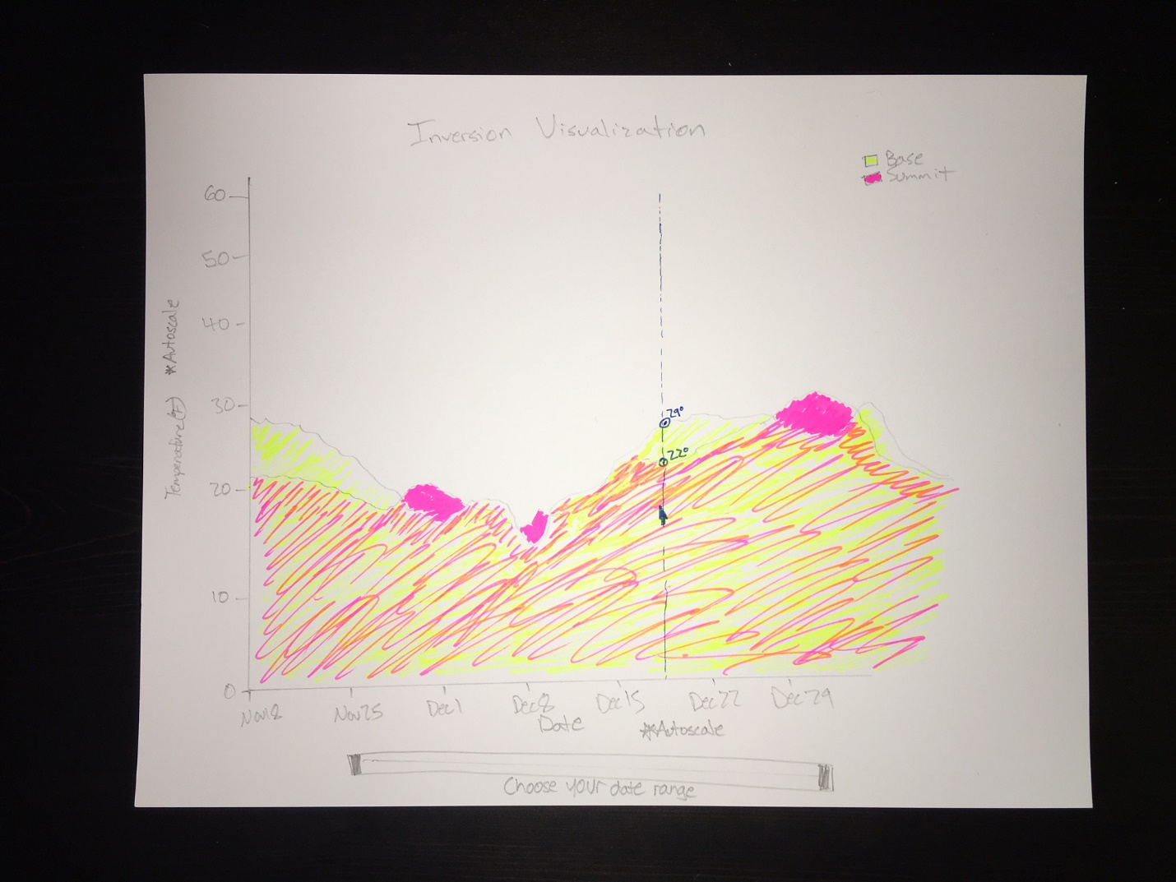 By displaying weather recordings at different altitudes over time, the viewer could be able to identify when inversion events occur, analyze the weather context around these events, and make new discoveries with regards to weather inversions. Although a line graph could present the data in a way that visually displays temperature data, using an area graph will allow for users to quickly recognize weather inversion events. In addition, by allowing the user to select the date range he would like to focus on, fine detail or a wider range of events can be shown. Select temperature ranges would not be ideal as it would create gaps in the data, resulting in empty ranges of displayed data. Finally, since a large number of recordings will likely be displayed on the area graph, an interactive tooltip would allow the user to make accurate comparisons in weather data at specific points in time. With these interactive visualization techniques, users will be able to explore weather data in a new, intuitive way, allowing them to be able to even look for more than just weather inversion events.

## Final Product:

The final interactive visualization almost fully encapsulates the ideas from the initial design sketch. Upon loading of the weather data, the graph scales the x and y axes to fit the data. Initially, all of the weather data is displayed, with the base’s area having a 0.8 opacity to allow the viewer to also see the summit temperature’s line and area as well. Inversion events can easily be noticed because the summit weather data shows its full saturation when it rises above the base temperature area.

In order to allow for an accurate comparison of temperatures at a certain time, tooltips are displayed on the data points that correlate to the x-axis location of the user’s cursor. I decided to drop the vertical line that would extend from the bottom to the top of the graph along this x-axis location as it did not prove to assist the user in more easily or accurately interpreting the data. All that was necessary was a locator along the temperature lines as well as a tooltip displaying the weather data.

In addition, the user is able to select a date range using a slider. Upon selection of a new date range, the graph updates, displaying only data within the specified range and rescaling the resulting data to fill the full dimensions of the graph area, updating the axes to properly represent the data as well.

## Source Code and Working Example:

The working interactive visualization can be viewed here:   
 <https://students.washington.edu/cjustice/D3SnoqualmiePassInversionVisualization/d3viz.html>

A zip file of the files can be downloaded here:  
 <https://github.com/cjustice10/D3SnoqualmiePassInversionVisualization/archive/master.zip>

## Discussion:

During the development of this application, I encountered many roadblocks that required rewriting large portions of my code in order to appropriately manipulate and display the data with new tools. In his book *Data Drive Documents D3.JS Tips and Tricks*, Malcolm Maclean provides a foundations upon which I was able to display two line graphs on an appropriately scaled set of axes, however working through the many steps required to fill in the areas, display multiple tool tips as the cursor moved, filter manipulated data and rescale the axes appropriately required endless head scratches

Allowing the user to select a date range using a slider ended up taking the largest amount of time to research and implement however, as the jQueryUI sliders do not work with filtering dates. In the end, I discovered the jQRangeSlider, which provides the necessary functionality, however has very little documentation. Many nights were spent attempting to incorporate the slider into my code so that the dates presented by the slider were able to filter and update the dates from my data source.

The result has turned out as I had hoped, and I do believe that the challenges I encountered with the displaying of multiple area graphs, discovering the nuances of data types, and reading the documentation of many tools to discover how and if I could incorporate them into my application allowed me to gain a much deeper understanding of how D3 is able to incorporate a number of libraries and data types in order to render visualizations for almost any use case.